ACI XXX.XR

“REPORT ON …” or “GUIDE TO…”
The title of the document appears prominently on the first page of the draft document. The title of the document should include either the word “guide” or “report,” depending on the document, and indicate the subject matter, for example, “Report on ….” or “Guide for…”

Reported by ACI Committee XXX

XXXXX  Chair | XXXXI  Secretary

Voting Member | Voting Member | Voting Member | Voting Member
Voting Member | Voting Member | Voting Member | Voting Member
Voting Member | Voting Member | Voting Member | Voting Member
Voting Member | Voting Member | Voting Member | Voting Member
Voting Member | Voting Member | Voting Member | Voting Member
Voting Member | Voting Member | Voting Member | Voting Member

All voting members (of the main committee and the subcommittee that developed the document) and consulting members at the time of the opening date of a document’s final letter ballot before submission for TAC review are listed on the roster published on the front page of the committee document. Associate members are not listed. When a committee reapproves a document, the committee roster published with the original document is retained, and the roster of the current committee is not shown.
The chair may list other individuals who contributed to the document and should receive recognition.
Place an appropriate note immediately below the roster. The acknowledgement note should not list specific contributions. An example of an appropriate note is: “Special acknowledgements to {list of individuals} for their contributions to this [report or guide].”
The final technical ballot is defined as the last letter ballot that contained an item that completed the document, allowing the committee to submit it for TAC review. A technical ballot item to find negative votes from previous ballots nonpersuasive is not considered a final technical ballot. Balloting information and tools are found on the ACI website under Publications, Technical Documents, and Document Development.

A one- or two-paragraph synopsis should state the document’s scope and purpose, and should inform and spark interest without going into too much detail. Each synopsis is printed in Concrete International (CI), and should therefore make sense when read independently of the document.

Keywords: A list of items discussed in the document that aid users in retrieving material. The title, synopsis, and table of contents of the document are good sources for keywords. Approximately three to 10 keywords are required. The keywords should reflect the document’s subject matter without being too general. For example, avoid listing “concrete” or “water-cement ratio.” List keywords in alphabetical order and separate them with semicolons. Do not use multiple forms of the same word as keywords.

CONTENTS
A table of contents includes titles of chapters and sections. Do not include page numbers in the table of contents; page numbers are assigned by staff after final formatting of the document.

Chapter 1—Introduction and Scope
1.1—Introduction
1.2—Scope
Chapter 2—Notation and definitions
2.1—Notation
2.2—Definitions
Chapter 3—Body of document
3.1—Section heading
3.2—Section heading
3.3—Section heading
Chapter 4— Body of document
4.1— Section heading
4.2—Section heading
Chapter X—References
Appendix A

CHAPTER 1—INTRODUCTION AND SCOPE

1.1—Introduction

The introduction provides the history and context of the information.

1.2—Scope

The scope may provide a brief description of each chapter in the document.
Introduction (1 .1) and Scope (1 .2)—provides the history, the scope of the document and context of the information, and may provide a brief description of each chapter in the document.

CHAPTER 2—NOTATION AND DEFINITIONS

2.1—NOTATION
Alphabetical order-Roman followed by Greek letters, uppercase letters first
A_{g} = gross area of concrete section, in.² (mm²)
C_{vxm} = seismic distribution factor of the m-th mode
c_{c} = clear cover from the nearest surface in tension to the surface of the flexural torsion reinforcement, in. (mm)
β = ratio of distances to the neutral axis from the extreme tension fiber and from the centroid of the main reinforcement
ρ_{v} = ratio of vertical distributed shear reinforcement on a vertical plane

2.2—DEFINITIONS
Definitions and notation—list the notation used throughout document. Arrange in alphabetical order, with roman letters appearing first and Greek letters at the end. Upper-case letters should come before lower-case letters in the list. Define technical terms that are unique to the document. Refer to, “ACI Concrete Terminology,” (CT) on the ACI website at http://terminology.concrete.org for general technical terms.
For documents with terms defined, add the following statement:
ACI provides a comprehensive list of definitions through an online resource, “ACI Concrete Terminology,” http://terminology.concrete.org. Definitions provided here complement that source.
column—member with a ratio of height-to-least-lateral dimension exceeding 3 used primarily to support axial compressive load.
compression member––any member in which the primary stress is longitudinal compression.
epoxy— a thermosetting polymer that is the reaction product of epoxy resin and an amino hardener. (See also epoxy resin.)

CHAPTER 3—BODY OF DOCUMENT
Chapters and sections should have titles. Items may or may not be titled, but number them consecutively following the decimal designation system. The numbering system should not exceed four levels.
3.1—Introduction
Reinforced concrete structures continue to be designed in accordance with national or international consensus codes and standards such as ACI 318, Eurocode 2 (CEN 2006), and the fib Model Code, MC 2010 (fib 2013). The codes are developed and based on knowledge acquired in research and testing laboratories, and supplemented by field experience. Although present design procedures for concrete are dominated by analytical determinations based on strength principles, designs are increasingly being refined to address durability requirements. Examples include designs that consider resistance to chloride ingress and freezing-and-thawing resistance. Inherent with design calculations and construction documents developed in conformance with these codes is a certain level of durability, such as requirements for concrete cover to protect embedded steel reinforcement under aggressive environmental conditions.
3.2—Environmental considerations
Design of reinforced concrete structures to provide adequate durability is a complicated process. Service life depends on structural design and detailing, mixture proportioning, concrete production and placement, construction methods, and maintenance. Also, loading, environmental exposure, and changes in use are important. Because water or some other liquid is involved in almost every form of concrete degradation, concrete penetrability is important and is composed of three parts:
- Absorption is the process by which a liquid is drawn into and tends to fill permeable pores in a porous solid body; also the increase in mass of a porous solid body resulting from the penetration of a liquid into its permeable pores
- Permeability is the ease with which a liquid can flow through a solid under pressure
- Diffusion is the movement of one medium through another due to concentration gradients.
3.2.1 Chemical attack—Chemical attack involves the alteration of concrete through chemical reaction with either the cement paste, aggregate, or embedded steel reinforcement. Generally, the attack occurs on the exposed surface region of the concrete or cover concrete; however, with the presence of cracks or prolonged exposure, chemical attack can affect entire structural cross sections. Chemical causes of deterioration are grouped into three categories (Mehta 1986; Mindess et al. 2003; Nayak and Jain 2012):
- Hydrolysis of cement paste components by soft water
- Cation-exchange reactions between aggressive liquids and cement paste, including acid attack
- Reactions leading to formation of expansion product
Results from prolonged chemical attack range from cosmetic damage to loss of structural section and monolithic behavior. Chemical attack of embedded steel reinforcement can also occur.

CHAPTER XX—REFERENCES
Do not include bibliographies in ACI committee documents. Bibliographies list the references consulted in writing a document. References are only those sources that have been referenced in the document.
References should have the verbiage below and be setup as shown below.
ACI committee documents and documents published by other organizations are listed first by document number, full title, and year of publication followed by authored documents listed alphabetically.

American Concrete Institute
117-10 Specifications for Tolerances for Concrete Construction and Materials and Commentary
318-14 Building Code Requirements for Structural Concrete and Commentary
355.2-07 Qualifications of Post-Installed Mechanical Anchors in Concrete and Commentary
355.4-11 Qualifications of Post-Installed Adhesive Anchors in Concrete and Commentary
551.1R-14 Guide to Tilt-Up Concrete Construction

American Institute of Steel Construction
AISC 360-10 Specification for Structural Steel Buildings

American Society of Civil Engineers
ASCE/SEI 07-10 Minimum Design Loads for Buildings and Other Structures

Authored documents
Griffis, L. G. 1993, “Serviceability Limit States Under Wind Load,” Engineering Journal, V. 30, No. 1, pp. 1-16.
Lai, J.; Lawson, J.; Chukwuma, E.; Mehran, P.; and Lyon, B., 2006, “UBC 97 and ACI 318-02 Code Comparison—Summary Report,” SEAOSC Slender Wall Task Group, Structural Engineers Association of Southern California, Whittier, CA, 47 pp.
Uniform Building Code, 1997, “Structural Engineering Design Provisions,” International Conference of Building Officials, Whittier, CA, V. 2, Jan., 492 pp.
Zia, P., 1977, “Structural Design with High Strength Concrete,” Report No. PZIA-77-01, Civil Engineering
Department, North Carolina State University, Raleigh, NC, Mar., 65 pp.

APPENDIX A
Some documents use appendixes to present supplementary information such as long derivations, research data, or sample calculations. Use a separate appendix for each main purpose, lettered consecutively (Appendix A, Appendix B, etc.). Appendixes, if included, should follow the reference chapter. Appendixes should also be listed in the table of contents.

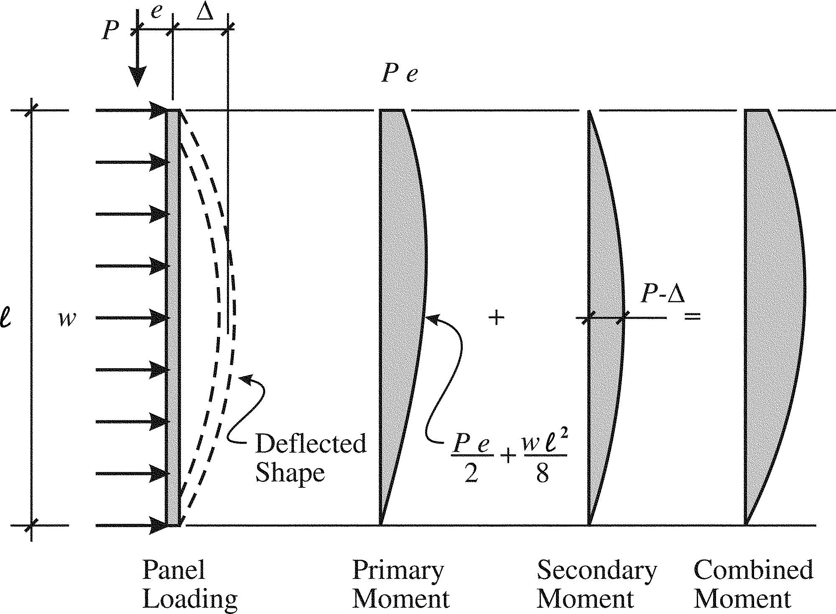
Fig. 3.1a—Panel design model–suction force acting with eccentric axial load.

Fig. 3.1b–– Example of equivalent square section for supporting members.

